EMAIL SETUP IN JENKINS
- Login to Jenkins.
- Click on “Manage Jenkins”.
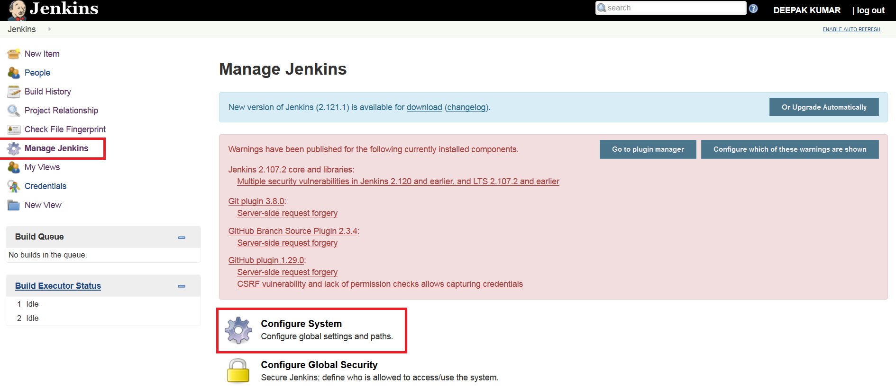
- Click on configure System.
- Enter SMTP server detail under “Extended E-mail Notification” and click on “Advance” button.
SMTP Server: smtp.gmail.com
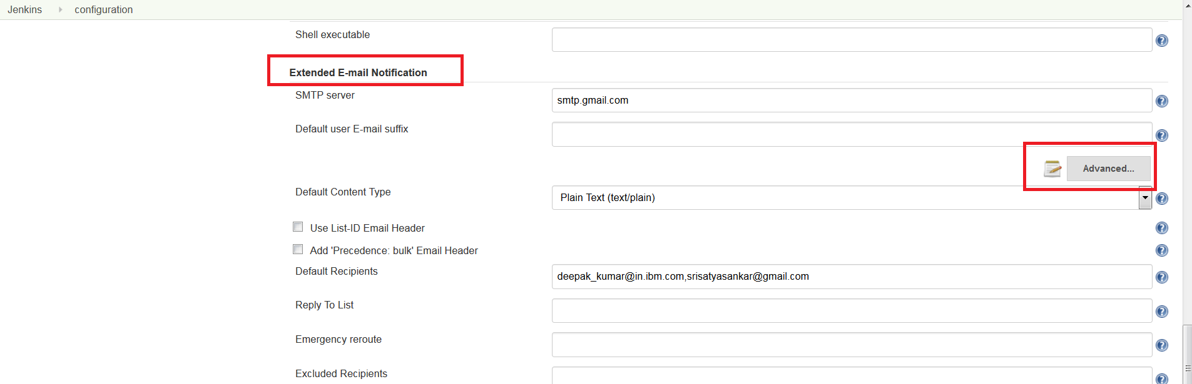
- Select “Use SMTP Authentication”-→Enter any gmail username and password → Select “Use SSl” and enter “SMTP port” as 465.
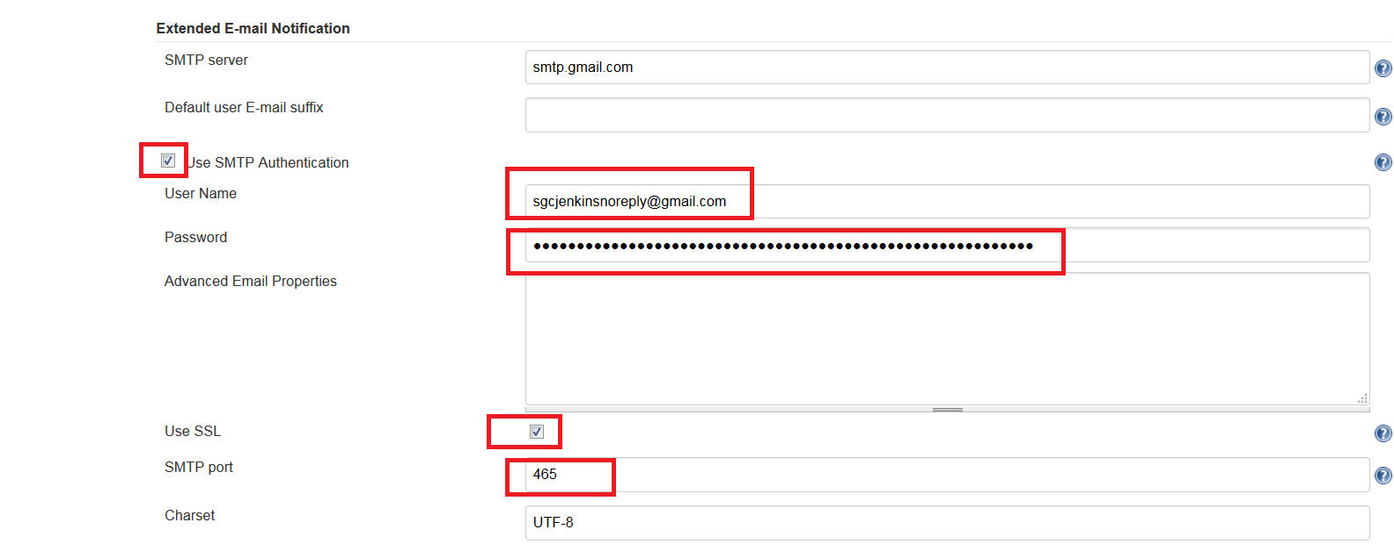
- Click on “Apply” and “Save” button.
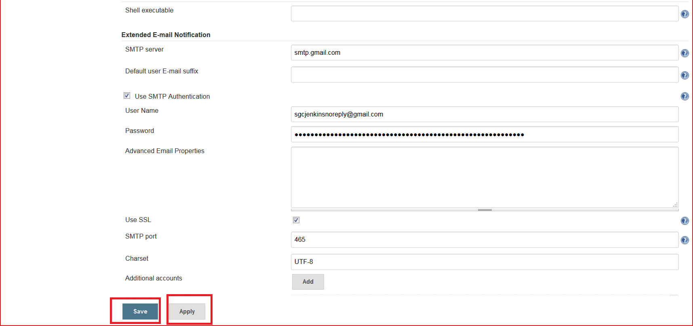
- Now click to Jenkins available at top left panel (Marked red in below snapshot) and then click on required item ( Example : Check the status of given file in Activity Management Page)
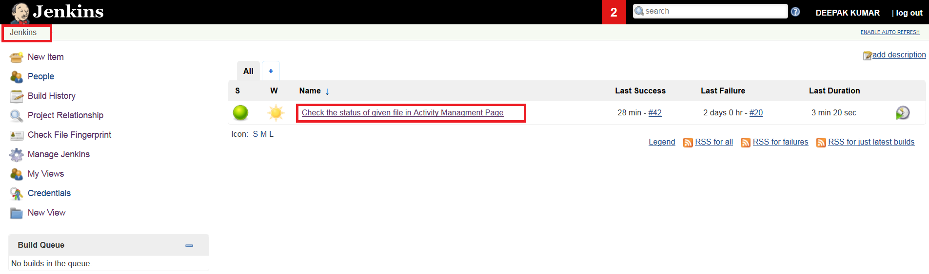
- Click on configure from left menu.
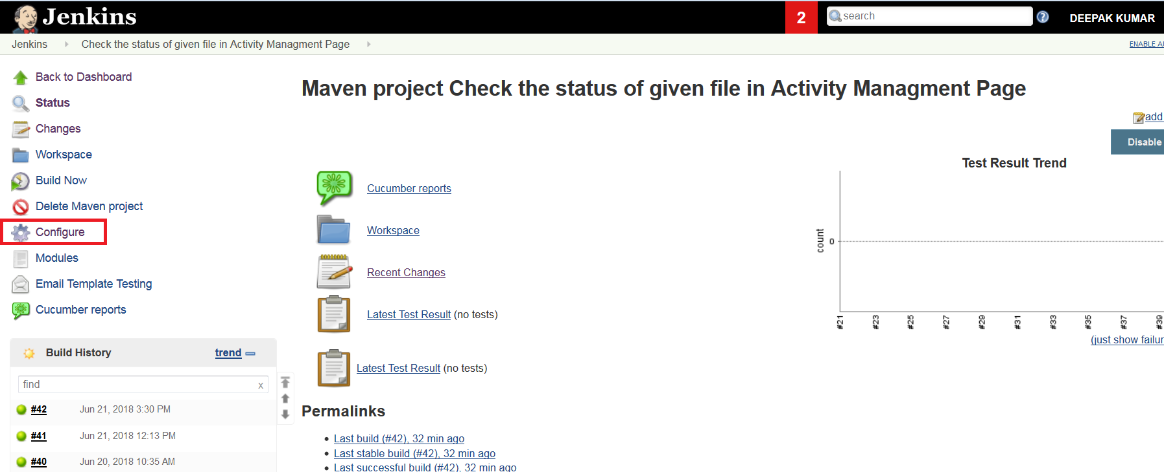
- Click on Post-build Actions from top panel and click on “Add post build action” in order to select “Editable Email Notification”.
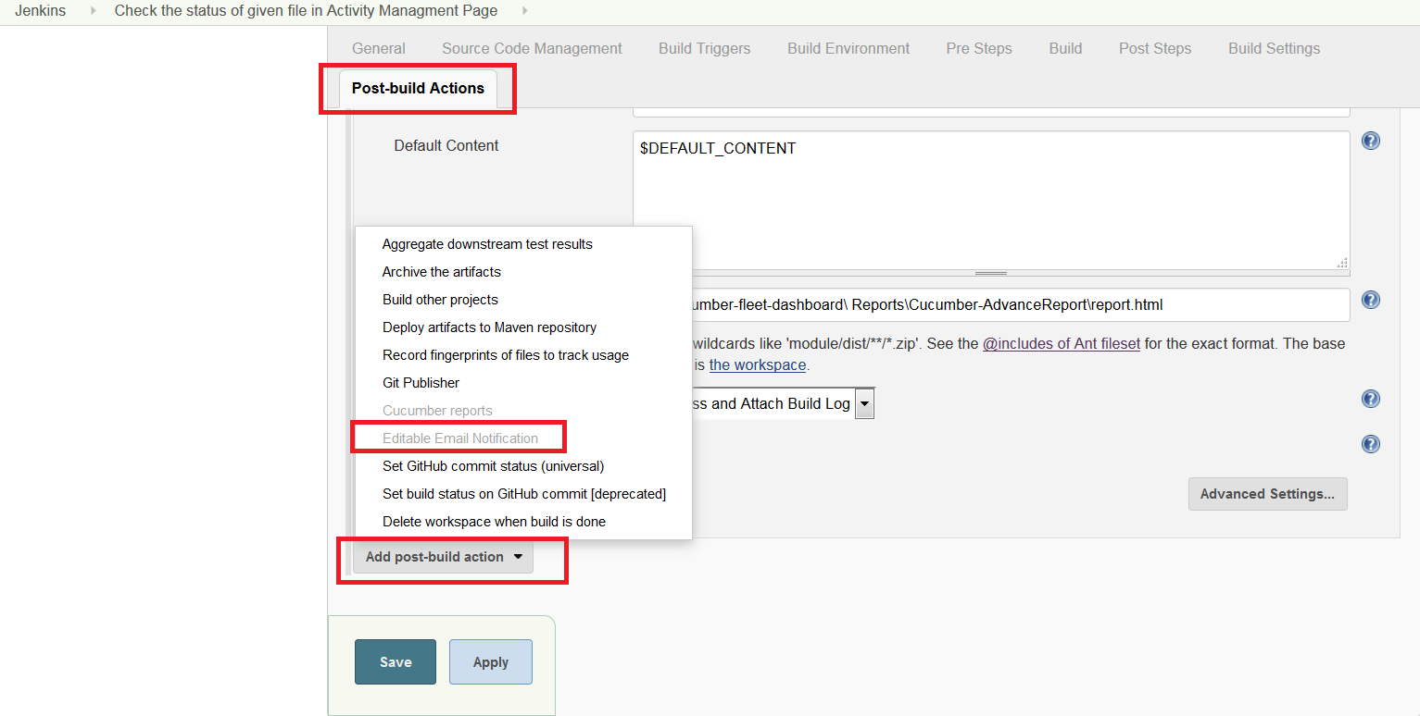
- Select Content Type as “Both HTML and Plain Text”.
Enter Default Subject as SGC Automation Result - $PROJECT_NAME- Build #$BUILD_NUMBER - $BUILD_STATUS
Enter Default Content as $DEFAULT_CONTENT
Enter HTML path in Attachment field ( Example : sgc-cucumber-fleet-dashboard\ Reports\Cucumber-AdvanceReport\report.html)
Note: Before entering HTML path in the attachment field, Click on Build from top panel and then click on “Advanced ” button. Select “Use custom workspace” and enter the Workspace directory path. This path can be easily retrieve by properties option in IDE (Eclipse)
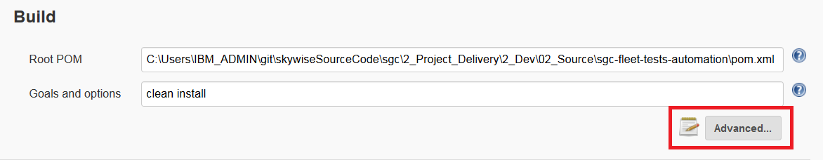

Select “Compress and Attached build Log” from “Attach Build Log” drop down list.
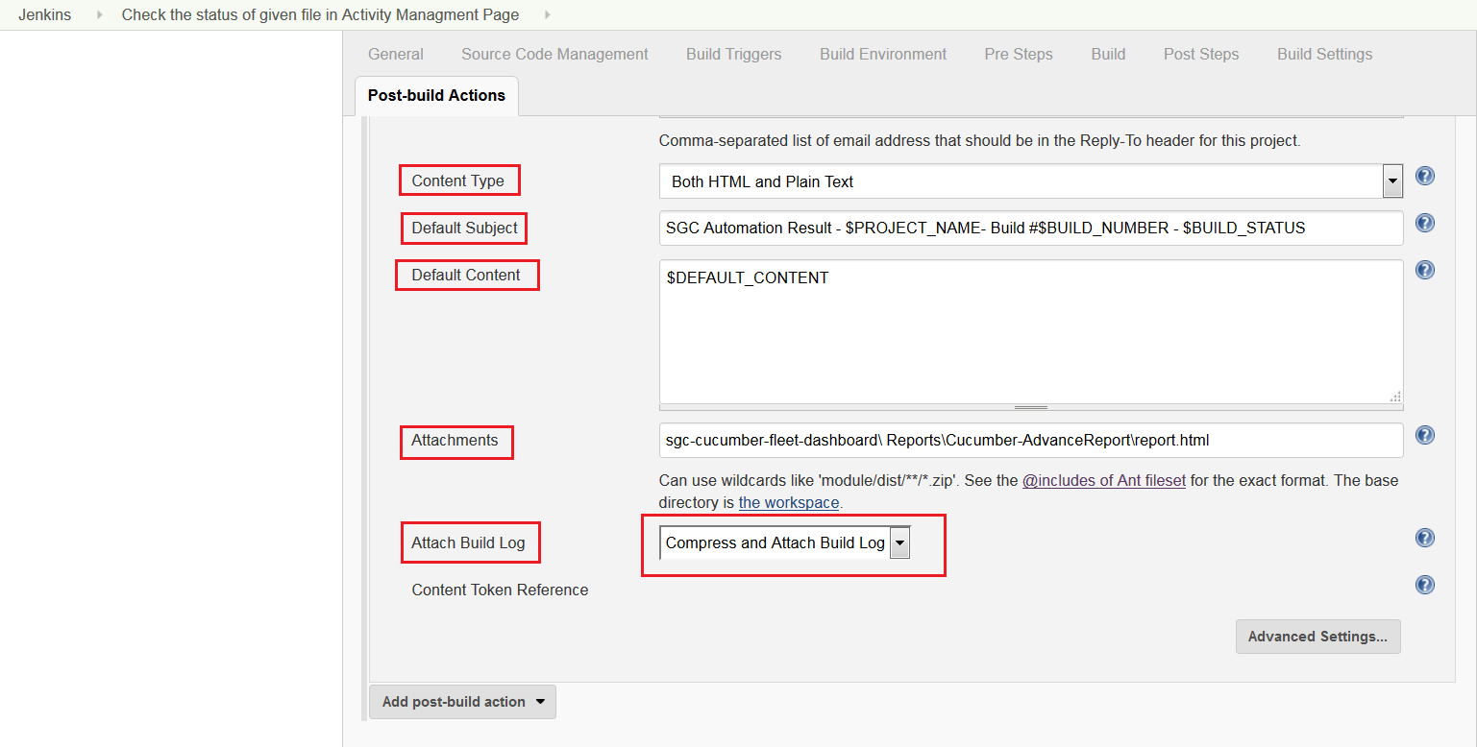

- Click on Advance Settings button under “Editable Email Notification”.
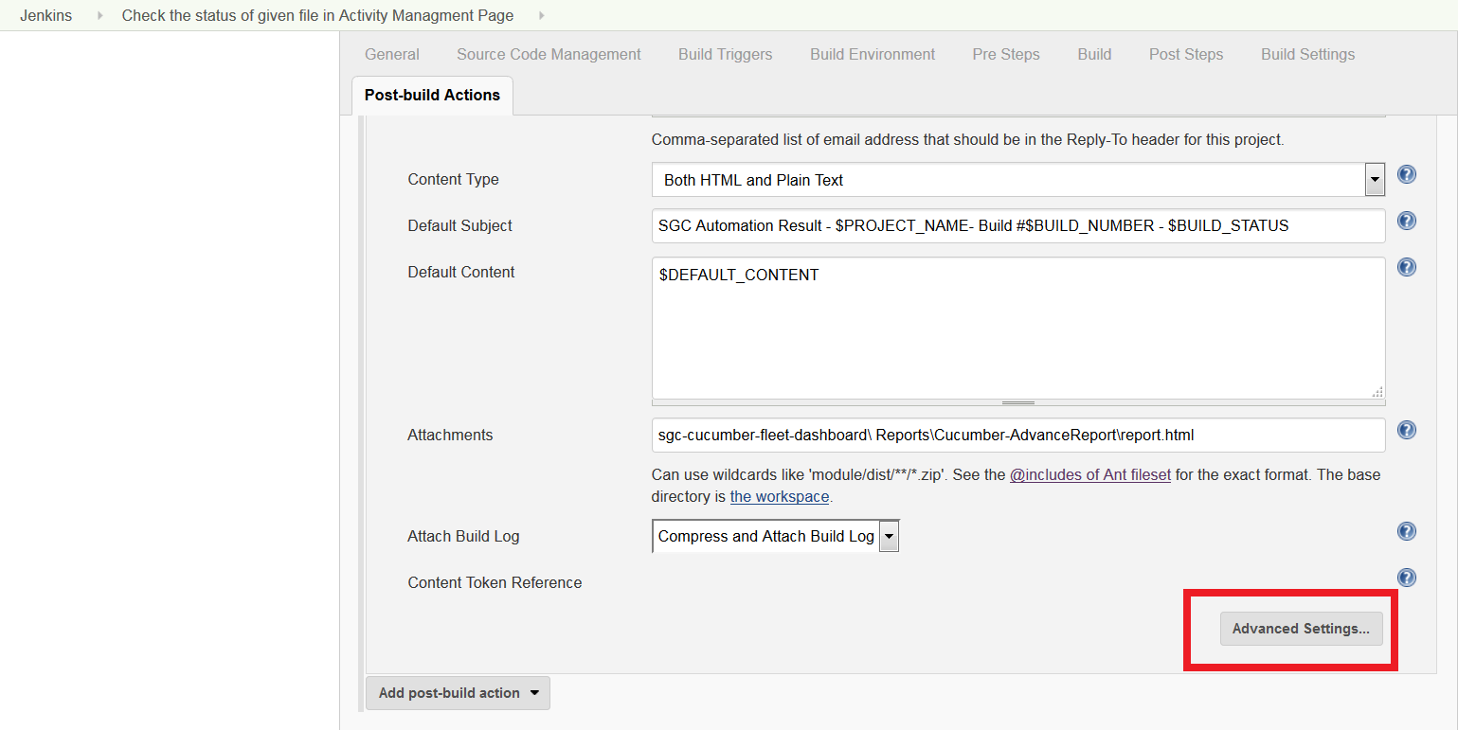
- Click on Add Trigger and Select “Success” then click on “Advanced”
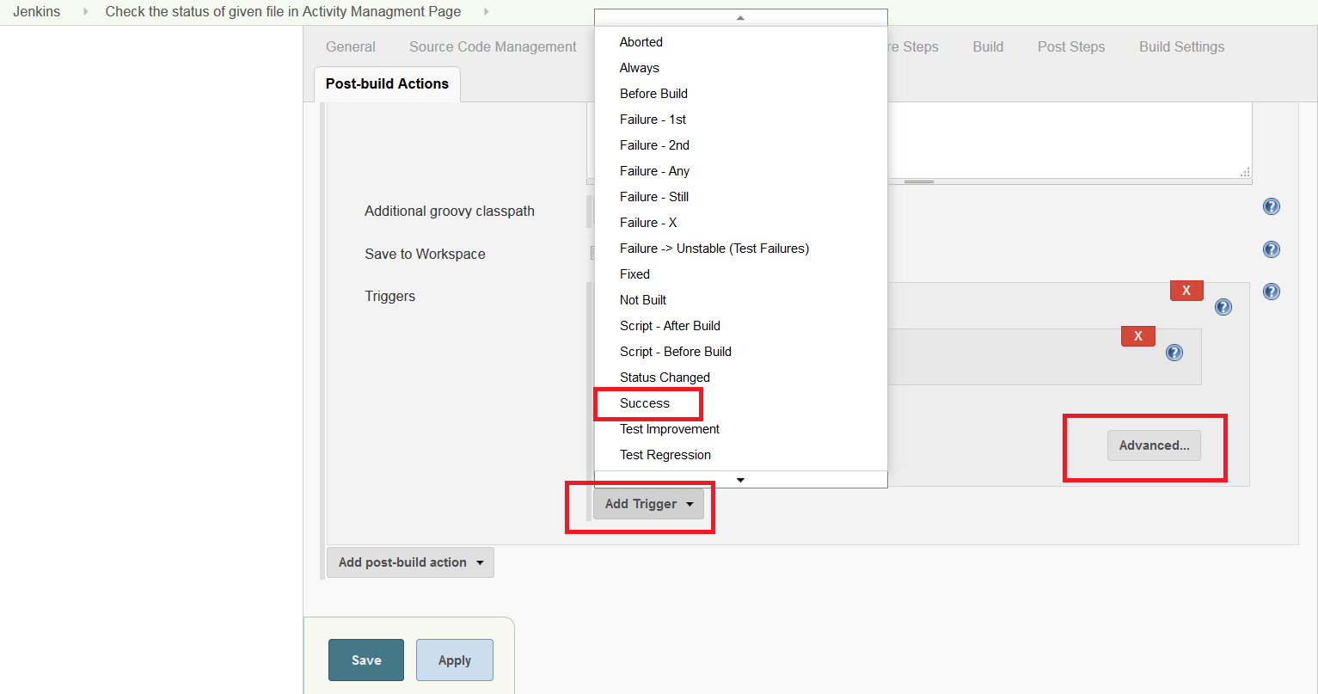
- Enter Recipient List (Example : deepak_kumar@in.ibm.com,singh.ranjit@in.ibm.com) and Reply-To-List ( Example : deepak_kumar@in.ibm.com,singh.ranjit@in.ibm.com)
Enter HTML path in Attachment field (Example : sgc-cucumber-fleet-dashboard\ Reports\Cucumber-AdvanceReport\report.html)
Select “Compress and Attached build Log” from “Attach Build Log” drop down list.

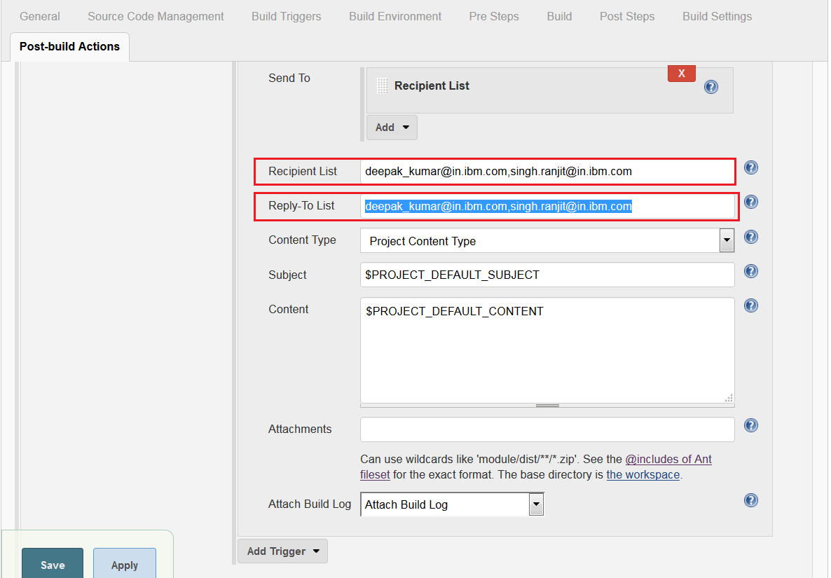
- Click on Apply and then Save button.

